P2 Individual Average data- all slopes vary by **subject**, intercept varies by **electrode** (Model 1)

Linear mixed model fit by REML

t-tests use Satterthwaite approximations to degrees of freedom ['lmerMod']

Formula: AvgAmp ~ faceRace * FixArea + (faceRace * FixArea | Subject) + (1 | Electrode)

Data: select

REML criterion at convergence: 5261

Scaled residuals:

Min 1Q Median 3Q Max

-3.4068 -0.5752 -0.0030 0.5835 4.5517

Random effects:

Groups Name Variance Std.Dev. Corr

Subject (Intercept) 6.88687 2.6243

faceRaceWhite 1.23250 1.1102 -0.22

FixAreafore 2.26126 1.5037 -0.43 0.18

faceRaceWhite:FixAreafore 1.95764 1.3992 0.24 -0.57 -0.49

Electrode (Intercept) 0.04923 0.2219

Residual 0.66810 0.8174

Number of obs: 1820, groups: Subject, 65; Electrode, 7

Fixed effects:

Estimate Std. Error df t value Pr(>|t|)

(Intercept) 1.9849 0.3383 69.1600 5.867 1.39e-07 ***

faceRaceWhite -0.8563 0.1480 64.0000 -5.787 2.34e-07 ***

FixAreafore -0.5012 0.1942 64.0000 -2.580 0.0122 *

faceRaceWhite:FixAreafore 0.2599 0.1897 64.0000 1.370 0.1754

AIC BIC logLik deviance df.resid

5286.723 5374.829 -2627.362 5254.723 1804.000

P2 Individual Average data- predicted slopes and intercepts for each effect for each subject

$Subject

(Intercept) faceRaceWhite FixAreafore faceRaceWhite:FixAreafore

1 5.159345890 -0.065082889 -1.46829751 -0.78900846

2 2.080452264 -1.120955864 -1.01199701 0.19257913

3 5.362344161 -2.378587505 -1.24372025 1.87066129

4 1.992165246 -0.187672084 -0.89077439 1.29917468

5 4.049110134 -0.722510711 -0.06415035 0.08797713

6 2.095101380 -0.970497661 -0.92790770 0.65399695

7 2.297091535 -1.941238778 1.11005755 -0.73135719

8 -1.898820394 1.296144126 0.66954502 -1.41670342

9 3.774791309 -1.088509419 -1.74733600 0.78857697

10 2.762154362 -0.680482754 1.04537607 0.14576578

11 2.427145580 -1.834062030 -0.88164670 1.03451750

12 1.514017314 -0.336615136 -0.47943515 0.37496590

13 0.340380066 0.249538184 -1.23135875 1.10207490

14 -1.420221793 -1.077070692 0.63381720 1.69203920

15 3.878488026 -1.722488386 -2.20875178 1.64238857

16 4.322608159 -0.273244198 -0.75440346 1.48072082

17 0.377064841 0.500601485 0.57993763 -2.05312625

18 4.307222365 -4.481144205 -0.08500921 0.27094276

19 4.371761762 -0.683024076 -0.69787213 0.46844724

20 -1.165883362 -0.669519529 0.39027740 -0.73097447

21 0.817291274 0.005233616 -0.42336508 0.57072132

22 -2.432064026 0.807275707 1.43810945 -1.18444959

23 5.379909890 0.271905483 -1.61608893 0.07877986

24 4.466315601 -0.740010228 -1.55262845 0.01274243

25 -1.049051295 -1.483591580 -3.31600233 0.79741016

26 -3.007412208 -1.257123418 0.15397359 0.13298951

27 0.967566401 0.007416111 2.97826862 -0.90186115

28 3.034626960 -0.650223019 -1.69224640 0.50286660

29 -2.554403957 -0.301022930 0.12802628 -0.60678605

30 6.192249766 -0.295565072 -1.03524855 -0.01023867

31 4.309053151 -0.435492441 -2.51059031 -0.51114528

32 3.712642827 -1.122440733 -1.65324250 1.05022090

33 5.405572236 -0.941980233 -3.22639108 2.78857665

$Electrode

(Intercept) faceRaceWhite FixAreafore faceRaceWhite:FixAreafore

C3 1.994333 -0.8562923 -0.5012002 0.2599325

C4 1.670968 -0.8562923 -0.5012002 0.2599325

CP3 1.962923 -0.8562923 -0.5012002 0.2599325

CP4 1.741540 -0.8562923 -0.5012002 0.2599325

CPZ 2.189898 -0.8562923 -0.5012002 0.2599325

CZ 2.250599 -0.8562923 -0.5012002 0.2599325

PZ 2.083768 -0.8562923 -0.5012002 0.2599325

P2 Trial by trial data- all slopes vary by **subject**, intercept varies by **electrode** (Model 1)

Linear mixed model fit by REML

t-tests use Satterthwaite approximations to degrees of freedom ['lmerMod']

Formula: MeanAmp ~ Race * Fix + (Race * Fix | Subject) + (1 | Electrode)

Data: dat

REML criterion at convergence: 1407083

Scaled residuals:

Min 1Q Median 3Q Max

-7.0150 -0.6352 -0.0057 0.6256 6.6307

Random effects:

Groups Name Variance Std.Dev. Corr

Subject (Intercept) 6.88921 2.625

RaceWhite 1.15699 1.076 -0.22

Fixforehead 2.19594 1.482 -0.44 0.20

RaceWhite:Fixforehead 1.88687 1.374 0.25 -0.58 -0.48

Electrode (Intercept) 0.04972 0.223

Residual 76.00920 8.718

Number of obs: 196168, groups: Subject, 65; Electrode, 7

Fixed effects:

Estimate Std. Error df t value Pr(>|t|)

(Intercept) 1.9881 0.3386 69.1900 5.871 1.36e-07 ***

RaceWhite -0.8407 0.1447 62.3400 -5.809 2.30e-07 ***

Fixforehead -0.5374 0.1922 63.8400 -2.796 0.00683 **

RaceWhite:Fixforehead 0.2996 0.1880 62.1100 1.593 0.11614

AIC BIC logLik deviance df.resid

1407108.8 1407271.8 -703538.4 1407076.8 196152.0 P2 Trial by trial data- predicted slopes and intercepts for each effect for each subject

$Subject

(Intercept) RaceWhite Fixforehead RaceWhite:Fixforehead

1 5.164689548 -0.080218996 -1.47873736 -0.7660306339

2 2.080734631 -1.119530700 -1.01618060 0.1980823998

3 5.353940899 -2.354923954 -1.24152570 1.8552495026

4 2.000194637 -0.203390908 -0.87772642 1.2481177314

5 4.051034716 -0.724366358 -0.07342256 0.1020330207

6 2.094055695 -0.968417262 -0.92935386 0.6563441575

7 2.595211675 -1.125070776 -1.34109770 1.8994050675

8 -1.869425607 1.241427624 0.64176360 -1.3639820857

9 3.754398543 -1.069980700 -1.71672828 0.7659528582

10 2.764065519 -0.681475491 1.03537531 0.1610595877

11 2.419089251 -1.817649716 -0.87846412 1.0267502937

12 1.514071200 -0.337633781 -0.48297263 0.3815810432

13 0.339835306 0.247553230 -1.23511227 1.1142559953

14 -1.423466729 -1.071728560 0.63926428 1.6913570608

15 3.879208185 -1.721880136 -2.20918936 1.6428264362

16 4.324240949 -0.277472667 -0.75414300 1.4898237642

17 0.424344643 0.424747099 0.50280110 -1.9300165169

18 4.287561533 -4.447494729 -0.08579521 0.2802637469

19 4.372784788 -0.686884600 -0.70287244 0.4786869323

20 -1.155965019 -0.678274324 0.36904772 -0.6955075773

21 0.815819986 0.005159720 -0.42529576 0.5813855247

22 -2.426731922 0.783968824 1.42997800 -1.1587989525

23 5.384317153 0.256597655 -1.61978541 0.0944355616

24 4.468763624 -0.740262941 -1.55870867 0.0179563098

25 -1.059010452 -1.468657509 -3.29707138 0.7818849967

26 -3.009612157 -1.251756195 0.15269349 0.1319851691

27 0.977987650 -0.004227589 2.95885408 -0.8759427423

28 3.036374455 -0.651880735 -1.69808449 0.5093772012

29 -2.552611900 -0.303225059 0.12437173 -0.6013070913

30 6.193575875 -0.296984968 -1.04082158 -0.0004378507

31 4.311831622 -0.437349402 -2.51531380 -0.5023356507

32 3.713127464 -1.123147712 -1.65727947 1.0574379925

33 5.397079526 -0.935304642 -3.18697954 2.7211681414

$Electrode

(Intercept) RaceWhite Fixforehead RaceWhite:Fixforehead

C3 1.992986 -0.8406721 -0.5373605 0.2995951

C4 1.671535 -0.8406721 -0.5373605 0.2995951

CP3 1.967876 -0.8406721 -0.5373605 0.2995951

CP4 1.744946 -0.8406721 -0.5373605 0.2995951

CPZ 2.199557 -0.8406721 -0.5373605 0.2995951

CZ 2.248329 -0.8406721 -0.5373605 0.2995951

PZ 2.091505 -0.8406721 -0.5373605 0.2995951

P2 Trial by trial data- all slopes vary by **subject**, intercept varies by **electrode** and **trial** (Model 3)

Linear mixed model fit by REML

t-tests use Satterthwaite approximations to degrees of freedom ['lmerMod']

Formula: MeanAmp ~ Race * Fix + (Race * Fix | Subject) + (1 | Electrode) + (1 | Trial)

Data: dat

REML criterion at convergence: 1404919

Scaled residuals:

Min 1Q Median 3Q Max

-6.9955 -0.6350 -0.0078 0.6255 6.7571

Random effects:

Groups Name Variance Std.Dev. Corr

Trial (Intercept) 1.23229 1.1101

Subject (Intercept) 6.91178 2.6290

RaceWhite 1.15258 1.0736 -0.23

Fixforehead 2.11130 1.4530 -0.45 0.18

RaceWhite:Fixforehead 1.93190 1.3899 0.27 -0.57 -0.47

Electrode (Intercept) 0.04977 0.2231

Residual 74.78680 8.6479

Number of obs: 196168, groups: Trial, 512; Subject, 65; Electrode, 7

Fixed effects:

Estimate Std. Error df t value Pr(>|t|)

(Intercept) 2.0067 0.3427 72.1400 5.856 1.30e-07 ***

RaceWhite -0.8535 0.1445 62.2700 -5.906 1.58e-07 ***

Fixforehead -0.5683 0.1888 63.8000 -3.010 0.00374 **

RaceWhite:Fixforehead 0.3498 0.1899 61.8500 1.843 0.07019 .

AIC BIC logLik deviance df.resid

1404946.6 1405119.8 -702456.3 1404912.6 196151.0 P2 Trial by trial data- BLUPs for trial (predicted intercept for each trial)

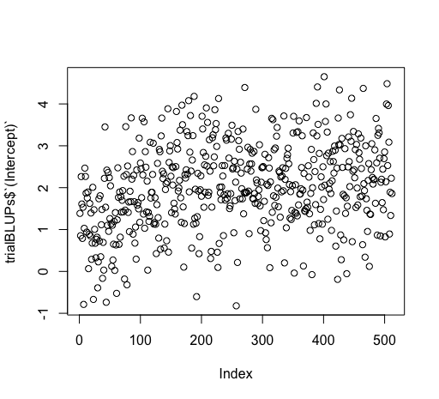

P2 Trial by trial data- all slopes vary by **subject** and **trial**, intercept varies by **electrode** (Model 4.2)

Linear mixed model fit by REML

t-tests use Satterthwaite approximations to degrees of freedom ['lmerMod']

Formula: MeanAmp ~ Race * Fix + (Race * Fix | Subject) + (1 | Electrode) + (Race * Fix | Trial)

Data: dat

REML criterion at convergence: 1399626

Scaled residuals:

Min 1Q Median 3Q Max

-7.0430 -0.6333 -0.0066 0.6279 6.5225

Random effects:

Groups Name Variance Std.Dev. Corr

Trial (Intercept) 4.59073 2.1426

RaceWhite 9.02126 3.0035 -0.70

Fixforehead 7.79977 2.7928 -0.69 0.48

RaceWhite:Fixforehead 16.89793 4.1107 0.50 -0.70 -0.69

Subject (Intercept) 6.93995 2.6344

RaceWhite 1.27698 1.1300 -0.23

Fixforehead 2.20365 1.4845 -0.45 0.20

RaceWhite:Fixforehead 2.18807 1.4792 0.29 -0.59 -0.49

Electrode (Intercept) 0.04988 0.2233

Residual 71.71587 8.4685

Number of obs: 196168, groups: Trial, 512; Subject, 65; Electrode, 7

Fixed effects:

Estimate Std. Error df t value Pr(>|t|)

(Intercept) 2.0341 0.3528 80.3000 5.766 1.45e-07 ***

RaceWhite -0.8563 0.2010 178.6300 -4.260 3.31e-05 ***

Fixforehead -0.6043 0.2287 123.3300 -2.643 0.00929 **

RaceWhite:Fixforehead 0.3753 0.2702 186.2900 1.389 0.16643

AIC BIC logLik deviance df.resid

1399672.8 1399937.6 -699810.4 1399620.8 196142.0 P2 Trial by trial data- BLUPs for trial (predicted slope for Race and Fix for each trial)

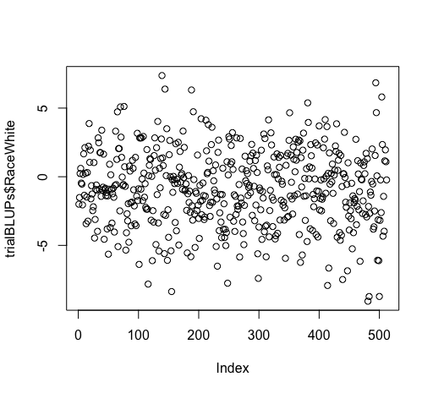 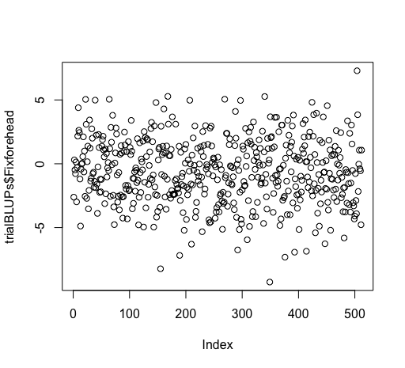

P2 Trial by trial data- all slopes vary by **subject**, intercept varies by **electrode,** add fixed effect of **trial** (not included in email)

Linear mixed model fit by REML

t-tests use Satterthwaite approximations to degrees of freedom ['lmerMod']

Formula: MeanAmp ~ Race * Fix + Trial + (Race * Fix | Subject) + (1 | Electrode)

Data: dat

REML criterion at convergence: 1406822

Scaled residuals:

Min 1Q Median 3Q Max

-7.0164 -0.6344 -0.0054 0.6260 6.6652

Random effects:

Groups Name Variance Std.Dev. Corr

Subject (Intercept) 6.88023 2.623

RaceWhite 1.15071 1.073 -0.21

Fixforehead 2.18703 1.479 -0.43 0.20

RaceWhite:Fixforehead 1.87778 1.370 0.24 -0.58 -0.48

Electrode (Intercept) 0.04973 0.223

Residual 75.90231 8.712

Number of obs: 196168, groups: Subject, 65; Electrode, 7

Fixed effects:

Estimate Std. Error df t value Pr(>|t|)

(Intercept) 1.426e+00 3.401e-01 7.100e+01 4.192 7.89e-05 ***

RaceWhite -8.423e-01 1.444e-01 6.200e+01 -5.834 2.09e-07 ***

Fixforehead -5.382e-01 1.918e-01 6.400e+01 -2.806 0.00665 **

Trial 2.234e-03 1.341e-04 1.960e+05 16.658 < 2e-16 ***

RaceWhite:Fixforehead 3.058e-01 1.876e-01 6.200e+01 1.630 0.10819

AIC BIC logLik deviance df.resid

1406833.5 1407006.7 -703399.7 1406799.5 196151.0 P2 Trial by trial data- all slopes vary by **subject**, intercept varies by **electrode,** fixed effect of **trial and interactions** (Model 5.2)

Linear mixed model fit by REML

t-tests use Satterthwaite approximations to degrees of freedom ['lmerMod']

Formula: MeanAmp ~ Race * Fix * Trial + (Race * Fix | Subject) + (1 | Electrode)

Data: dat

REML criterion at convergence: 1406843

Scaled residuals:

Min 1Q Median 3Q Max

-7.0177 -0.6341 -0.0050 0.6262 6.6797

Random effects:

Groups Name Variance Std.Dev. Corr

Subject (Intercept) 6.87619 2.622

RaceWhite 1.14832 1.072 -0.21

Fixforehead 2.19380 1.481 -0.43 0.20

RaceWhite:Fixforehead 1.88920 1.374 0.24 -0.58 -0.48

Electrode (Intercept) 0.04972 0.223

Residual 75.89512 8.712

Number of obs: 196168, groups: Subject, 65; Electrode, 7

Fixed effects:

Estimate Std. Error df t value Pr(>|t|)

(Intercept) 1.157e+00 3.451e-01 7.500e+01 3.354 0.001252 **

RaceWhite -5.098e-01 1.730e-01 1.290e+02 -2.946 0.003819 **

Fixforehead -1.372e-01 2.147e-01 1.000e+02 -0.639 0.524213

Trial 3.301e-03 2.695e-04 1.959e+05 12.251 < 2e-16 ***

RaceWhite:Fixforehead -9.030e-02 2.315e-01 1.420e+02 -0.390 0.697072

RaceWhite:Trial -1.320e-03 3.791e-04 1.958e+05 -3.483 0.000496 ***

Fixforehead:Trial -1.592e-03 3.806e-04 1.959e+05 -4.184 2.86e-05 ***

RaceWhite:Fixforehead:Trial 1.570e-03 5.363e-04 1.958e+05 2.928 0.003412 **

P2 Binned data- all slopes vary by **subject**, intercept varies by **electrode** (Model 1)

Linear mixed model fit by REML

t-tests use Satterthwaite approximations to degrees of freedom ['lmerMod']

Formula: MeanAmp ~ Race * Fix + (Race * Fix | Subject) + (1 | Electrode)

Data: binDat

REML criterion at convergence: 122777.2

Scaled residuals:

Min 1Q Median 3Q Max

-5.0195 -0.6335 -0.0092 0.6329 4.1925

Random effects:

Groups Name Variance Std.Dev. Corr

Subject (Intercept) 6.854 2.6180

RaceWhite 1.228 1.1081 -0.20

Fixforehead 2.326 1.5253 -0.40 0.22

RaceWhite:Fixforehead 2.147 1.4654 0.19 -0.59 -0.51

Electrode (Intercept) 0.048 0.2191

Residual 9.998 3.1620

Number of obs: 23730, groups: Subject, 65; Electrode, 7

Fixed effects:

Estimate Std. Error df t value Pr(>|t|)

(Intercept) 1.9701 0.3377 69.0900 5.835 1.58e-07 ***

RaceWhite -0.8199 0.1494 61.9300 -5.489 8.00e-07 ***

Fixforehead -0.5149 0.1980 63.6000 -2.600 0.0116 *

RaceWhite:Fixforehead 0.2615 0.1998 61.3200 1.309 0.1955

AIC BIC logLik deviance df.resid

122803.09 122932.28 -61385.55 122771.09 23714.00

P2 Binned data- predicted slopes and intercepts for each effect for each subject

$Subject

(Intercept) RaceWhite Fixforehead RaceWhite:Fixforehead

1 5.02895660 -0.18357728 -1.21920577 -0.80728510

2 1.51724926 -0.56797717 -0.44730412 -0.52446368

3 5.41075293 -2.27497519 -1.41014175 1.71512813

4 2.02503579 -0.03816048 -0.63367439 0.84275708

5 3.82440400 -0.50717981 0.15994386 -0.24224163

6 2.32040239 -0.85589700 -0.99681579 0.40408165

7 2.23164438 -0.47758337 -1.16032461 1.74460414

8 -1.88831689 1.43809926 0.66105356 -1.59091008

9 3.80652392 -0.86698829 -1.73487146 0.56365852

10 2.75443286 -0.72539096 1.04919741 0.14393185

11 2.40387490 -1.78947087 -0.79922024 0.86977006

12 1.50141911 -0.52183648 -0.48884776 0.59192431

13 0.23729690 0.40509112 -1.22489515 1.07448093

14 -1.39620473 -1.05165059 0.34906698 1.77015973

15 3.53845089 -1.44975956 -1.87909853 1.43208423

16 4.39916799 -0.34837385 -0.76384905 1.43015379

17 0.30763079 0.79226019 0.60306174 -2.18458418

18 3.97357142 -4.50013501 0.32230726 0.45146821

19 4.52706995 -0.75044058 -0.90221313 0.64901324

20 -1.13904158 -0.69252926 0.36838444 -0.77353757

21 0.87321215 -0.09084831 -0.47568035 1.02305921

22 -2.38566870 0.85581419 1.57696159 -1.40672255

23 5.27282295 0.32073279 -1.14531462 -0.35035625

24 4.45702872 -0.79095700 -1.62527872 0.28187930

25 -1.10814417 -1.47573001 -3.76338122 1.14900628

26 -2.99546841 -1.16474658 0.15042283 0.43633680

27 1.04295565 -0.10320977 2.92014068 -0.62232816

28 2.92566993 -0.42996298 -1.63407996 0.40460321

29 -2.56909522 -0.56056464 0.04098105 -0.21124022

30 6.24478264 -0.28918585 -1.00366896 -0.02060527

31 4.36252407 -0.28584331 -2.61177854 -0.47198661

32 3.71314370 -1.26486873 -1.65274468 1.28628541

33 5.43836427 -0.81244309 -3.17056046 2.60843094

$Electrode

(Intercept) RaceWhite Fixforehead RaceWhite:Fixforehead

C3 1.973973 -0.8199252 -0.5149421 0.2614972

C4 1.664773 -0.8199252 -0.5149421 0.2614972

CP3 1.946039 -0.8199252 -0.5149421 0.2614972

CP4 1.731426 -0.8199252 -0.5149421 0.2614972

CPZ 2.177370 -0.8199252 -0.5149421 0.2614972

CZ 2.231904 -0.8199252 -0.5149421 0.2614972

PZ 2.065311 -0.8199252 -0.5149421 0.2614972

P2 Binned data- all slopes vary by **subject**, intercept varies by **electrode** and **bin** (Model 2)

Linear mixed model fit by REML

t-tests use Satterthwaite approximations to degrees of freedom ['lmerMod']

Formula: MeanAmp ~ Race * Fix + (Race * Fix | Subject) + (1 | Electrode) + (1 | Bin)

Data: binDat

REML criterion at convergence: 122365

Scaled residuals:

Min 1Q Median 3Q Max

-5.1469 -0.6320 -0.0141 0.6338 4.0888

Random effects:

Groups Name Variance Std.Dev. Corr

Subject (Intercept) 6.83967 2.6153

RaceWhite 1.23765 1.1125 -0.19

Fixforehead 2.31127 1.5203 -0.40 0.22

RaceWhite:Fixforehead 2.15694 1.4687 0.19 -0.59 -0.51

Bin (Intercept) 0.19259 0.4388

Electrode (Intercept) 0.04806 0.2192

Residual 9.80419 3.1312

Number of obs: 23730, groups: Subject, 65; Bin, 15; Electrode, 7

Fixed effects:

Estimate Std. Error df t value Pr(>|t|)

(Intercept) 2.0031 0.3560 80.3500 5.627 2.59e-07 ***

RaceWhite -0.8174 0.1497 61.9900 -5.462 8.85e-07 ***

Fixforehead -0.5122 0.1973 63.6600 -2.596 0.0117 *

RaceWhite:Fixforehead 0.2638 0.1999 61.3600 1.320 0.1918

AIC BIC logLik deviance df.resid

122393.0 122530.3 -61179.5 122359.0 23713.0

P2 Binned data- BLUPs for trial (predicted intercept for each trial)

$Bin

(Intercept) RaceWhite Fixforehead RaceWhite:Fixforehead

1 1.042564 -0.8174181 -0.5122436 0.2637646

2 1.028934 -0.8174181 -0.5122436 0.2637646

3 1.726636 -0.8174181 -0.5122436 0.2637646

4 2.023237 -0.8174181 -0.5122436 0.2637646

5 2.303240 -0.8174181 -0.5122436 0.2637646

6 2.090978 -0.8174181 -0.5122436 0.2637646

7 2.222788 -0.8174181 -0.5122436 0.2637646

8 2.077927 -0.8174181 -0.5122436 0.2637646

9 2.085659 -0.8174181 -0.5122436 0.2637646

10 2.088867 -0.8174181 -0.5122436 0.2637646

11 2.425219 -0.8174181 -0.5122436 0.2637646

12 2.170792 -0.8174181 -0.5122436 0.2637646

13 2.385239 -0.8174181 -0.5122436 0.2637646

14 2.361539 -0.8174181 -0.5122436 0.2637646

15 2.012944 -0.8174181 -0.5122436 0.2637646

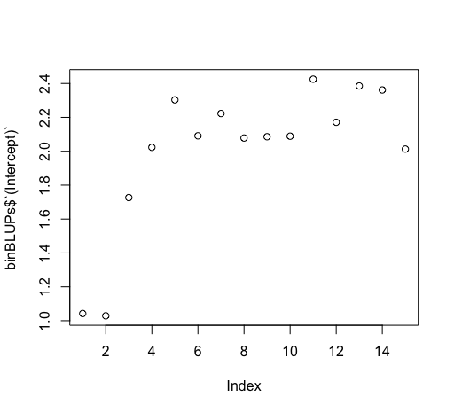

P2 Binned data- all slopes vary by **subject** and **bin**, intercept varies by **electrode** (Model 4.1)

Linear mixed model fit by REML

t-tests use Satterthwaite approximations to degrees of freedom ['lmerMod']

Formula: MeanAmp ~ Race * Fix + (Race * Fix | Subject) + (1 | Electrode) + (Race * Fix | Bin)

Data: binDat

REML criterion at convergence: 122247.9

Scaled residuals:

Min 1Q Median 3Q Max

-5.0960 -0.6352 -0.0168 0.6319 4.0695

Random effects:

Groups Name Variance Std.Dev. Corr

Subject (Intercept) 6.82851 2.6131

RaceWhite 1.24228 1.1146 -0.20

Fixforehead 2.32650 1.5253 -0.40 0.22

RaceWhite:Fixforehead 2.16302 1.4707 0.19 -0.59 -0.51

Bin (Intercept) 0.43421 0.6589

RaceWhite 0.24964 0.4996 -0.61

Fixforehead 0.29138 0.5398 -0.81 0.68

RaceWhite:Fixforehead 0.78049 0.8835 0.56 -0.91 -0.75

Electrode (Intercept) 0.04808 0.2193

Residual 9.72916 3.1192

Number of obs: 23730, groups: Subject, 65; Bin, 15; Electrode, 7

Fixed effects:

Estimate Std. Error df t value Pr(>|t|)

(Intercept) 2.0032 0.3779 80.2600 5.301 9.92e-07 ***

RaceWhite -0.8222 0.1987 35.1100 -4.137 0.000209 ***

Fixforehead -0.5179 0.2428 53.9900 -2.133 0.037513 *

RaceWhite:Fixforehead 0.2645 0.3051 26.5100 0.867 0.393868

AIC BIC logLik deviance df.resid

122295.19 122505.12 -61121.59 122243.19 23704.00

P2 Binned data- BLUPs for trial (predicted slope for Race and Fix for each trial)

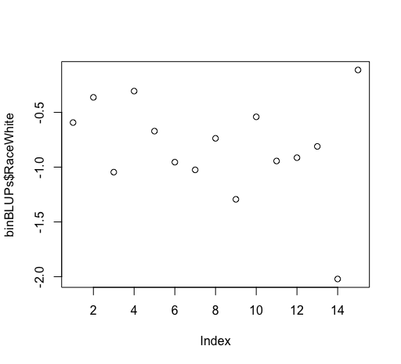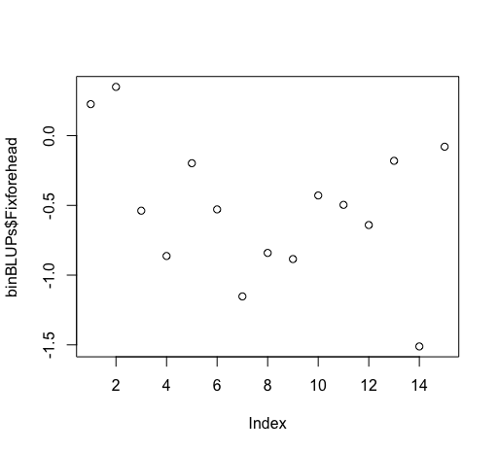

P2 Binned data- all slopes vary by **subject**, intercept varies by **electrode,** add fixed effect of **bin** (Not included in email)

Linear mixed model fit by REML

t-tests use Satterthwaite approximations to degrees of freedom ['lmerMod']

Formula: MeanAmp ~ Race * Fix + Bin + (Race * Fix | Subject) + (1 | Electrode)

Data: binDat

REML criterion at convergence: 122521.4

Scaled residuals:

Min 1Q Median 3Q Max

-5.1577 -0.6313 -0.0119 0.6332 4.2172

Random effects:

Groups Name Variance Std.Dev. Corr

Subject (Intercept) 6.84244 2.6158

RaceWhite 1.24275 1.1148 -0.20

Fixforehead 2.30865 1.5194 -0.41 0.22

RaceWhite:Fixforehead 2.14457 1.4644 0.19 -0.59 -0.51

Electrode (Intercept) 0.04804 0.2192

Residual 9.88661 3.1443

Number of obs: 23730, groups: Subject, 65; Electrode, 7

Fixed effects:

Estimate Std. Error df t value Pr(>|t|)

(Intercept) 1.362e+00 3.394e-01 7.100e+01 4.013 0.000147 ***

RaceWhite -8.180e-01 1.500e-01 6.200e+01 -5.452 9.17e-07 ***

Fixforehead -5.165e-01 1.973e-01 6.400e+01 -2.618 0.011031 *

Bin 8.629e-02 5.291e-03 2.349e+04 16.309 < 2e-16 ***

RaceWhite:Fixforehead 2.695e-01 1.995e-01 6.100e+01 1.351 0.181688

AIC BIC logLik deviance df.resid

122540.6 122677.9 -61253.3 122506.6 23713.0

P2 Binned data- all slopes vary by **subject**, intercept varies by **electrode,** add fixed effect of **bin and interactions** (Model 5.1)

Linear mixed model fit by REML

t-tests use Satterthwaite approximations to degrees of freedom ['lmerMod']

Formula: MeanAmp ~ Race * Fix * Bin + (Race * Fix | Subject) + (1 | Electrode)

Data: binDat

REML criterion at convergence: 122525.6

Scaled residuals:

Min 1Q Median 3Q Max

-5.1502 -0.6306 -0.0132 0.6365 4.2168

Random effects:

Groups Name Variance Std.Dev. Corr

Subject (Intercept) 6.84030 2.6154

RaceWhite 1.24834 1.1173 -0.20

Fixforehead 2.33245 1.5272 -0.41 0.23

RaceWhite:Fixforehead 2.16407 1.4711 0.19 -0.59 -0.51

Electrode (Intercept) 0.04804 0.2192

Residual 9.88072 3.1434

Number of obs: 23730, groups: Subject, 65; Electrode, 7

Fixed effects:

Estimate Std. Error df t value Pr(>|t|)

(Intercept) 1.109e+00 3.454e-01 7.600e+01 3.212 0.00194 **

RaceWhite -4.967e-01 1.834e-01 1.370e+02 -2.708 0.00763 **

Fixforehead -1.283e-01 2.242e-01 1.040e+02 -0.572 0.56846

Bin 1.221e-01 1.052e-02 2.350e+04 11.603 < 2e-16 ***

RaceWhite:Fixforehead -1.391e-01 2.493e-01 1.470e+02 -0.558 0.57785

RaceWhite:Bin -4.549e-02 1.489e-02 2.338e+04 -3.054 0.00226 **

Fixforehead:Bin -5.492e-02 1.481e-02 2.347e+04 -3.707 0.00021 ***

RaceWhite:Fixforehead:Bin 5.769e-02 2.108e-02 2.330e+04 2.737 0.00621 **